Chapter 4:
Controller Firmware

General Firmware Overview
Both the local controller code and Ethernet controller code were implemented on the same HCS12NE64 microcontroller. Both of them worked independently: the local controller made the sampling and controller action every standard timer interrupt, while the Ethernet controller code made the necessary communication actions every time a TCP packet was received. We have designed our system so that the timer interrupt would have the highest priority amongst all interrupts.
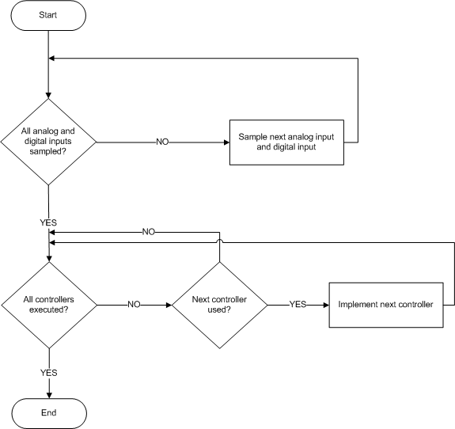
Figure 4.1 Summary of timer interrupt handler.
Every timer interrupt, the local controller samples all of the available channels and assigns them to global array. Therefore, this global array is updated regularly and it is available to be sent to any station on request. Thus, the sampling of the local controller is independent of the sampling of the station.
Each PID or On/Off controller has its own parameters set separately. Moreover, each controller may have its input and output channels set separately. To save time and power, while looping over all of the controllers, each controller is checked first whether it is actually needed or not.
Our local controller supports:
- 8 Analog Input Channels
- 8 Analog Output Channels
- 8 Digital Input Channels
- 8 Digital Output Channels
- 8 On/Off Controllers
- 8 PID Controllers
Each of the above features is implemented in the code as an array of structures. The same structure is used to represent an analog input channel and an analog output channel; but a flag is used to distinguish between them. The same could be said about digital input channels and digital output channels. Each channel has an associated Process ID with it. This is done to prevent any conflict which may occur when two different processes on the same microcontroller access the same channel. Such cases are handled in the PCSCP (Process Control Studio Communication Protocol).
Each controller has a pointer to its input channel and output channel. Before actually the executing the code for each controller, its mode bit is checked first to see if it is actually needed or not.
When sampling occurs, the value of each input channel structure is updated after reading the actual channel value. After the control action is taken, the actual output channels are written to and their corresponding channel structure values are updated.
Initially, all channels and controllers are set to OFF. The SP and other controller parameters are given some initial value which may be changed by any station. When a station connects to the microcontroller, it starts sending commands to the microcontroller to reserve the required channels and controllers and set the parameters of the required controllers. This is part of PCSCP and is discussed in more detail later in this documentation.
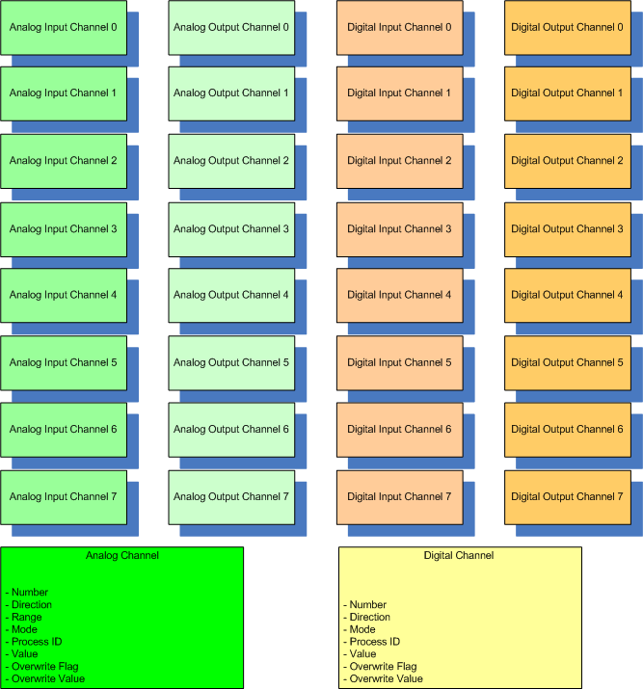
Figure 4.2 Channel structures and their members.
Structure Member | Meaning
Number | the number of the channel (initially set and remains constant and unique)
Mode | whether or not the channel is used
Direction | whether the channel is input or output
Value | the current value read or written to the channel
Overwrite Flag | whether or not a station has overwritten the value. Valid only for output channels.
Overwrite Value | value overwritten by the station.
Range | the electrical range of the channel, either: 0-5V or 0-10V or 4-20 mA.
ProcessID | to distinguish the process it belongs to.
Table 4.1 The meanings of each structure member.
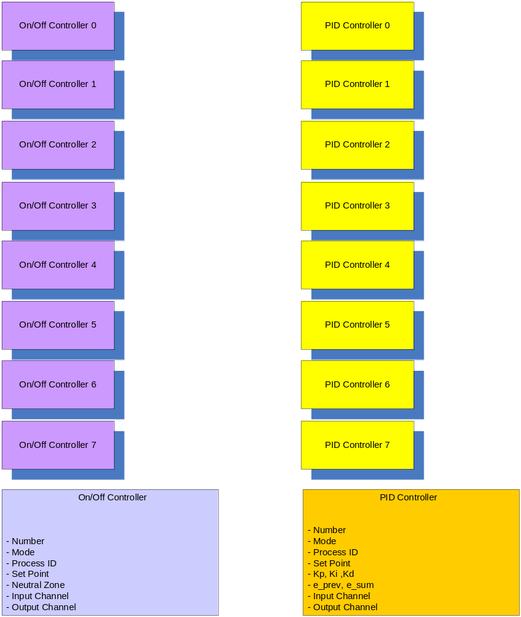
Figure 4.3 Controller structures and their members.
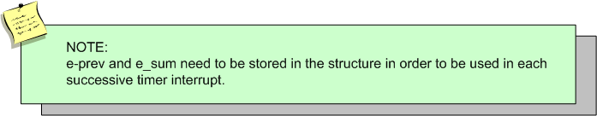

Commands and Requests
The local controller code should be able to receive commands via the Ethernet controller and interpret them in order to modify the controller parameters. Moreover, there is an available option to allow a user to force a value to an actuator. Therefore, the code has the ability to receive commands to overwrite a given analog or digital channel.
The following diagram explains how commands are sent to the local controller to modify any controller parameters. This is considered part of the PCSCP.
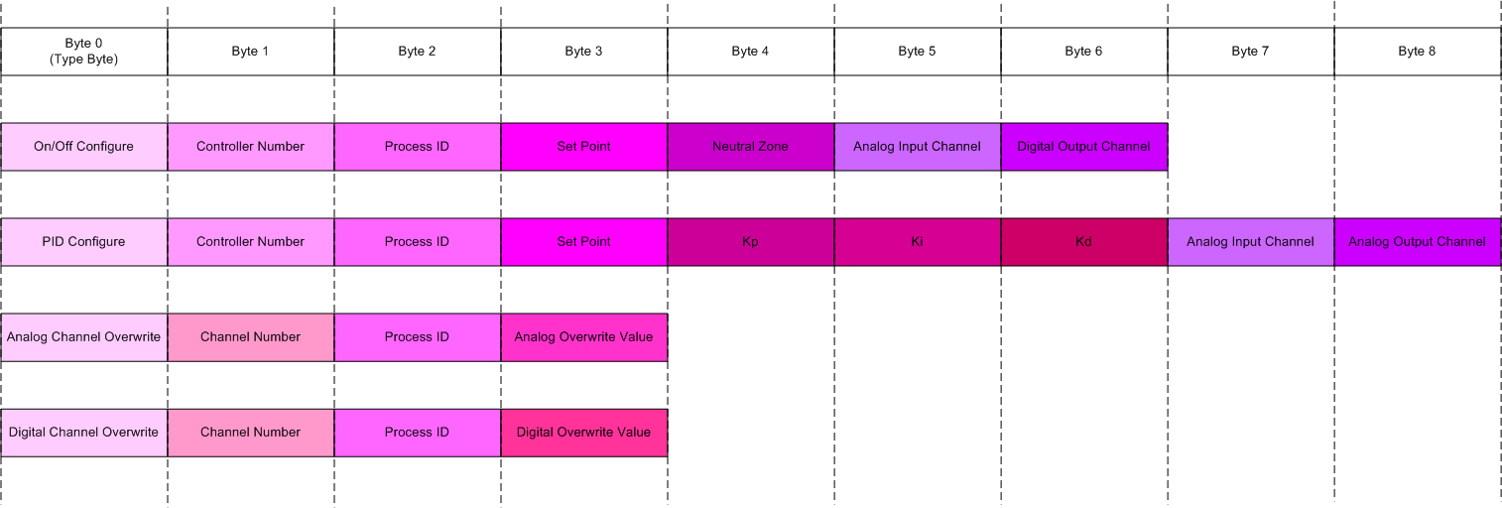
Figure 4.4Format of the commands to the controller.
